#First we have to download the SRA sequence from NCBI
#The current Paper that we have sited is:
#Chen, N., Shao, Q., Lu, Q., Li, X., & Gao, Y. (2022). Transcriptome analysis reveals differential transcription in tomato (Solanum lycopersicum) following inoculation with Ralstonia solanacearum. Scientific Reports, 12(1), 22137.
#For this paper the bio project is: PRJNA787007 Bioproject accession (SRA) in NCBI
#To download SRA files:
/home/BIB/Software/sratoolkit.3.2.1-alma_linux64/bin/fastq-dump --split-files -gzip SRR17163539
/home/BIB/Software/sratoolkit.3.2.1-alma_linux64/bin/fastq-dump --split-files -gzip SRR17163540
/home/BIB/Software/sratoolkit.3.2.1-alma_linux64/bin/fastq-dump --split-files -gzip SRR17163541
/home/BIB/Software/sratoolkit.3.2.1-alma_linux64/bin/fastq-dump --split-files -gzip SRR17163542
/home/BIB/Software/sratoolkit.3.2.1-alma_linux64/bin/fastq-dump --split-files -gzip SRR17163543
/home/BIB/Software/sratoolkit.3.2.1-alma_linux64/bin/fastq-dump --split-files -gzip SRR17163544
/home/BIB/Software/sratoolkit.3.2.1-alma_linux64/bin/fastq-dump --split-files -gzip SRR17163545
/home/BIB/Software/sratoolkit.3.2.1-alma_linux64/bin/fastq-dump --split-files -gzip SRR17163546
/home/BIB/Software/sratoolkit.3.2.1-alma_linux64/bin/fastq-dump --split-files -gzip SRR17163547
/home/BIB/Software/sratoolkit.3.2.1-alma_linux64/bin/fastq-dump --split-files -gzip SRR17163548
/home/BIB/Software/sratoolkit.3.2.1-alma_linux64/bin/fastq-dump --split-files -gzip SRR17163549
/home/BIB/Software/sratoolkit.3.2.1-alma_linux64/bin/fastq-dump --split-files -gzip SRR17163550

#For quality check of .fastq.gz files
nohup /home/BIB/Software/FastQC/fastqc /home/Chandrika/Transcriptomics/SRR17163539_1.fastq.gz /home/Chandrika/Transcriptomics/ SRR17163539_2.fastq.gz –o /home/Chandrika/Transcritomics &
nohup /home/BIB/Software/FastQC/fastqc /home/Chandrika/Transcriptomics/SRR17163540_1.fastq.gz /home/Chandrika/Transcriptomics/ SRR17163540_2.fastq.gz –o /home/Chandrika/Transcritomics &
nohup /home/BIB/Software/FastQC/fastqc /home/Chandrika/Transcriptomics/SRR17163541_1.fastq.gz /home/Chandrika/Transcriptomics/ SRR17163541_2.fastq.gz –o /home/Chandrika/Transcritomics &
nohup /home/BIB/Software/FastQC/fastqc /home/Chandrika/Transcriptomics/SRR17163542_1.fastq.gz /home/Chandrika/Transcriptomics/ SRR17163542_2.fastq.gz –o /home/Chandrika/Transcritomics &
nohup /home/BIB/Software/FastQC/fastqc /home/Chandrika/Transcriptomics/SRR17163543_1.fastq.gz /home/Chandrika/Transcriptomics/ SRR17163543_2.fastq.gz –o /home/Chandrika/Transcritomics &
nohup /home/BIB/Software/FastQC/fastqc /home/Chandrika/Transcriptomics/SRR17163544_1.fastq.gz /home/Chandrika/Transcriptomics/ SRR17163544_2.fastq.gz –o /home/Chandrika/Transcritomics &
nohup /home/BIB/Software/FastQC/fastqc /home/Chandrika/Transcriptomics/SRR17163545_1.fastq.gz /home/Chandrika/Transcriptomics/ SRR17163545_2.fastq.gz –o /home/Chandrika/Transcritomics &
nohup /home/BIB/Software/FastQC/fastqc /home/Chandrika/Transcriptomics/SRR17163546_1.fastq.gz /home/Chandrika/Transcriptomics/ SRR17163546_2.fastq.gz –o /home/Chandrika/Transcritomics &
nohup /home/BIB/Software/FastQC/fastqc /home/Chandrika/Transcriptomics/SRR17163547_1.fastq.gz /home/Chandrika/Transcriptomics/ SRR17163547_2.fastq.gz –o /home/Chandrika/Transcritomics &
nohup /home/BIB/Software/FastQC/fastqc /home/Chandrika/Transcriptomics/SRR17163548_1.fastq.gz /home/Chandrika/Transcriptomics/ SRR17163548_2.fastq.gz –o /home/Chandrika/Transcritomics &
nohup /home/BIB/Software/FastQC/fastqc /home/Chandrika/Transcriptomics/SRR17163549_1.fastq.gz /home/Chandrika/Transcriptomics/ SRR17163549_2.fastq.gz –o /home/Chandrika/Transcritomics &
nohup /home/BIB/Software/FastQC/fastqc /home/Chandrika/Transcriptomics/SRR17163550_1.fastq.gz /home/Chandrika/Transcriptomics/ SRR17163550_2.fastq.gz –o /home/Chandrika/Transcritomics &

#Trimmomatic (USADELLAB.org)
#It is used to remove adapter sequences and low-quality bases

nohup java -jar /home/BIB/Software/Trimmomatic-0.39/trimmomatic-0.39.jar PE -threads 8 /home/Chandrika/Transcriptomics/SRR17163539_1.fastq.gz /home/Chandrika/Transcriptomics/SRR17163539_2.fastq.gz /home/Chandrika/Transcriptomics/SRR17163539_1p.fastq.gz /home/Chandrika/SRR17163539_1u.fastq.gz /home/Chandrika/Transcriptomics/SRR17163539_2p.fastq.gz /home/Chandrika/SRR17163539_2u.fastq.gz ILLUMINACLIP:/home/BIB/Software/Trimmomatic-0.39/adapters/TruSeq3-PE.fa:2:30:10 LEADING:3 TRAILING:3 SLIDINGWINDOW:4:20 MINLEN:145 &
#Output at nohup, while starting and after completion:
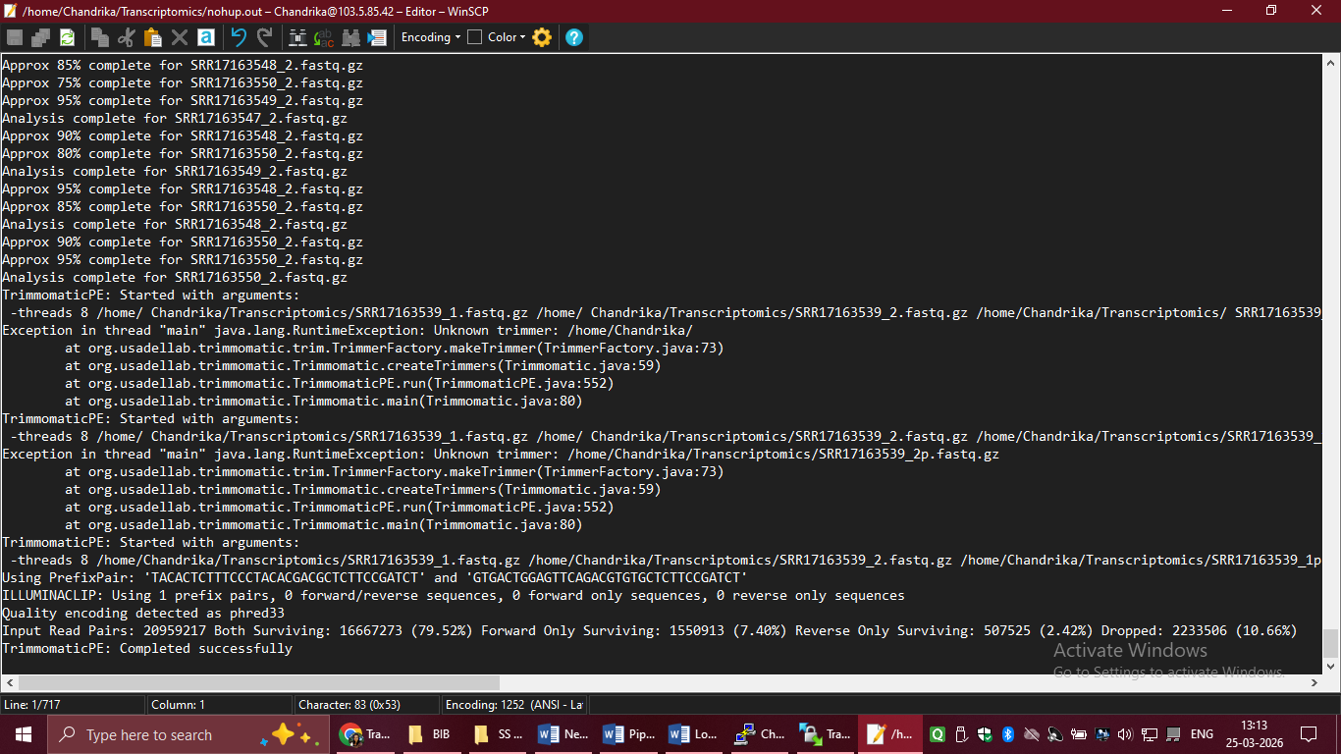
nohup java -jar /home/BIB/Software/Trimmomatic-0.39/trimmomatic-0.39.jar PE -threads 8 /home/Chandrika/Transcriptomics/SRR17163540_1.fastq.gz /home/Chandrika/Transcriptomics/SRR17163540_2.fastq.gz /home/Chandrika/Transcriptomics/SRR17163540_1p.fastq.gz /home/Chandrika/SRR17163540_1u.fastq.gz /home/Chandrika/Transcriptomics/SRR17163540_2p.fastq.gz /home/Chandrika/SRR17163540_2u.fastq.gz ILLUMINACLIP:/home/BIB/Software/Trimmomatic-0.39/adapters/TruSeq3-PE.fa:2:30:10 LEADING:3 TRAILING:3 SLIDINGWINDOW:4:20 MINLEN:145 &
nohup java -jar /home/BIB/Software/Trimmomatic-0.39/trimmomatic-0.39.jar PE -threads 8 /home/Chandrika/Transcriptomics/SRR17163541_1.fastq.gz /home/Chandrika/Transcriptomics/SRR17163541_2.fastq.gz /home/Chandrika/Transcriptomics/SRR17163541_1p.fastq.gz /home/Chandrika/SRR17163541_1u.fastq.gz /home/Chandrika/Transcriptomics/SRR17163541_2p.fastq.gz /home/Chandrika/SRR17163541_2u.fastq.gz ILLUMINACLIP:/home/BIB/Software/Trimmomatic-0.39/adapters/TruSeq3-PE.fa:2:30:10 LEADING:3 TRAILING:3 SLIDINGWINDOW:4:20 MINLEN:145 &
nohup java -jar /home/BIB/Software/Trimmomatic-0.39/trimmomatic-0.39.jar PE -threads 8 /home/Chandrika/Transcriptomics/SRR17163542_1.fastq.gz /home/Chandrika/Transcriptomics/SRR17163542_2.fastq.gz /home/Chandrika/Transcriptomics/SRR17163542_1p.fastq.gz /home/Chandrika/SRR17163542_1u.fastq.gz /home/Chandrika/Transcriptomics/SRR17163542_2p.fastq.gz /home/Chandrika/SRR17163542_2u.fastq.gz ILLUMINACLIP:/home/BIB/Software/Trimmomatic-0.39/adapters/TruSeq3-PE.fa:2:30:10 LEADING:3 TRAILING:3 SLIDINGWINDOW:4:20 MINLEN:145 &
nohup java -jar /home/BIB/Software/Trimmomatic-0.39/trimmomatic-0.39.jar PE -threads 8 /home/Chandrika/Transcriptomics/SRR17163543_1.fastq.gz /home/Chandrika/Transcriptomics/SRR17163543_2.fastq.gz /home/Chandrika/Transcriptomics/SRR17163543_1p.fastq.gz /home/Chandrika/SRR17163543_1u.fastq.gz /home/Chandrika/Transcriptomics/SRR17163543_2p.fastq.gz /home/Chandrika/SRR17163543_2u.fastq.gz ILLUMINACLIP:/home/BIB/Software/Trimmomatic-0.39/adapters/TruSeq3-PE.fa:2:30:10 LEADING:3 TRAILING:3 SLIDINGWINDOW:4:20 MINLEN:145 &
nohup java -jar /home/BIB/Software/Trimmomatic-0.39/trimmomatic-0.39.jar PE -threads 8 /home/Chandrika/Transcriptomics/SRR17163544_1.fastq.gz /home/Chandrika/Transcriptomics/SRR17163544_2.fastq.gz /home/Chandrika/Transcriptomics/SRR17163544_1p.fastq.gz /home/Chandrika/SRR17163544_1u.fastq.gz /home/Chandrika/Transcriptomics/SRR17163544_2p.fastq.gz /home/Chandrika/SRR17163544_2u.fastq.gz ILLUMINACLIP:/home/BIB/Software/Trimmomatic-0.39/adapters/TruSeq3-PE.fa:2:30:10 LEADING:3 TRAILING:3 SLIDINGWINDOW:4:20 MINLEN:145 &
nohup java -jar /home/BIB/Software/Trimmomatic-0.39/trimmomatic-0.39.jar PE -threads 8 /home/Chandrika/Transcriptomics/SRR17163545_1.fastq.gz /home/Chandrika/Transcriptomics/SRR17163545_2.fastq.gz /home/Chandrika/Transcriptomics/SRR17163545_1p.fastq.gz /home/Chandrika/SRR17163545_1u.fastq.gz /home/Chandrika/Transcriptomics/SRR17163545_2p.fastq.gz /home/Chandrika/SRR17163545_2u.fastq.gz ILLUMINACLIP:/home/BIB/Software/Trimmomatic-0.39/adapters/TruSeq3-PE.fa:2:30:10 LEADING:3 TRAILING:3 SLIDINGWINDOW:4:20 MINLEN:145 &
nohup java -jar /home/BIB/Software/Trimmomatic-0.39/trimmomatic-0.39.jar PE -threads 8 /home/Chandrika/Transcriptomics/SRR17163546_1.fastq.gz /home/Chandrika/Transcriptomics/SRR17163546_2.fastq.gz /home/Chandrika/Transcriptomics/SRR17163546_1p.fastq.gz /home/Chandrika/SRR17163546_1u.fastq.gz /home/Chandrika/Transcriptomics/SRR17163546_2p.fastq.gz /home/Chandrika/SRR17163546_2u.fastq.gz ILLUMINACLIP:/home/BIB/Software/Trimmomatic-0.39/adapters/TruSeq3-PE.fa:2:30:10 LEADING:3 TRAILING:3 SLIDINGWINDOW:4:20 MINLEN:145 &
nohup java -jar /home/BIB/Software/Trimmomatic-0.39/trimmomatic-0.39.jar PE -threads 8 /home/Chandrika/Transcriptomics/SRR17163547_1.fastq.gz /home/Chandrika/Transcriptomics/SRR17163547_2.fastq.gz /home/Chandrika/Transcriptomics/SRR17163547_1p.fastq.gz /home/Chandrika/SRR17163547_1u.fastq.gz /home/Chandrika/Transcriptomics/SRR17163547_2p.fastq.gz /home/Chandrika/SRR17163547_2u.fastq.gz ILLUMINACLIP:/home/BIB/Software/Trimmomatic-0.39/adapters/TruSeq3-PE.fa:2:30:10 LEADING:3 TRAILING:3 SLIDINGWINDOW:4:20 MINLEN:145 &
nohup java -jar /home/BIB/Software/Trimmomatic-0.39/trimmomatic-0.39.jar PE -threads 8 /home/Chandrika/Transcriptomics/SRR17163548_1.fastq.gz /home/Chandrika/Transcriptomics/SRR17163548_2.fastq.gz /home/Chandrika/Transcriptomics/SRR17163548_1p.fastq.gz /home/Chandrika/SRR17163548_1u.fastq.gz /home/Chandrika/Transcriptomics/SRR17163548_2p.fastq.gz /home/Chandrika/SRR17163548_2u.fastq.gz ILLUMINACLIP:/home/BIB/Software/Trimmomatic-0.39/adapters/TruSeq3-PE.fa:2:30:10 LEADING:3 TRAILING:3 SLIDINGWINDOW:4:20 MINLEN:145 &
nohup java -jar /home/BIB/Software/Trimmomatic-0.39/trimmomatic-0.39.jar PE -threads 8 /home/Chandrika/Transcriptomics/SRR17163549_1.fastq.gz /home/Chandrika/Transcriptomics/SRR17163549_2.fastq.gz /home/Chandrika/Transcriptomics/SRR17163549_1p.fastq.gz /home/Chandrika/SRR17163549_1u.fastq.gz /home/Chandrika/Transcriptomics/SRR17163549_2p.fastq.gz /home/Chandrika/SRR17163549_2u.fastq.gz ILLUMINACLIP:/home/BIB/Software/Trimmomatic-0.39/adapters/TruSeq3-PE.fa:2:30:10 LEADING:3 TRAILING:3 SLIDINGWINDOW:4:20 MINLEN:145 &
nohup java -jar /home/BIB/Software/Trimmomatic-0.39/trimmomatic-0.39.jar PE -threads 8 /home/Chandrika/Transcriptomics/SRR17163550_1.fastq.gz /home/Chandrika/Transcriptomics/SRR17163550_2.fastq.gz /home/Chandrika/Transcriptomics/SRR17163550_1p.fastq.gz /home/Chandrika/SRR17163550_1u.fastq.gz /home/Chandrika/Transcriptomics/SRR17163550_2p.fastq.gz /home/Chandrika/SRR17163550_2u.fastq.gz ILLUMINACLIP:/home/BIB/Software/Trimmomatic-0.39/adapters/TruSeq3-PE.fa:2:30:10 LEADING:3 TRAILING:3 SLIDINGWINDOW:4:20 MINLEN:145 &

#Now we have to download the reference genome sequence. For this project we have downloaded the ref genome from Solgenomics network.
#Solgenomics network>FTP site>Heinz1706>assembly>build_4.00>right click on S_lycopersicum_chromosomes.4.00.fa.gz and copy link address. Then go to the server and paste the link address at the desired place with command.
wget https://solgenomics.net/ftp/tomato_genome/Heinz1706/assembly/build_4.00/S_lycopersicum_chromosomes.4.00.fa.gz
#After downloading the ref genome, we have to index it
/home/BIB/Software/bwa/bwa index /home/Chandrika/Transcriptomics/S_lycopersicum_chromosomes.4.00.fa.gz
#For pairwise sequence alignment
nohup /home/BIB/Software/bwa/bwa mem /home/Chandrika/Transcriptomics/S_lycopersicum_chromosomes.4.00.fa.gz /home/Chandrika/Transcriptomics/SRR17163539_1p.fastq.gz /home/Chandrika/Transcriptomics/SRR17163539_2p.fastq.gz > Sl_aln_39.sam 2> Sl_aln_39.log &
nohup /home/BIB/Software/bwa/bwa mem /home/Chandrika/Transcriptomics/S_lycopersicum_chromosomes.4.00.fa.gz /home/Chandrika/Transcriptomics/SRR17163540_1p.fastq.gz /home/Chandrika/Transcriptomics/SRR17163540_2p.fastq.gz > Sl_aln_40.sam 2> Sl_aln_40.log &
nohup /home/BIB/Software/bwa/bwa mem /home/Chandrika/Transcriptomics/S_lycopersicum_chromosomes.4.00.fa.gz /home/Chandrika/Transcriptomics/SRR17163541_1p.fastq.gz /home/Chandrika/Transcriptomics/SRR17163541_2p.fastq.gz > Sl_aln_41.sam 2> Sl_aln_41.log &
nohup /home/BIB/Software/bwa/bwa mem /home/Chandrika/Transcriptomics/S_lycopersicum_chromosomes.4.00.fa.gz /home/Chandrika/Transcriptomics/SRR17163542_1p.fastq.gz /home/Chandrika/Transcriptomics/SRR17163542_2p.fastq.gz > Sl_aln_42.sam 2> Sl_aln_42.log &
nohup /home/BIB/Software/bwa/bwa mem /home/Chandrika/Transcriptomics/S_lycopersicum_chromosomes.4.00.fa.gz /home/Chandrika/Transcriptomics/SRR17163543_1p.fastq.gz /home/Chandrika/Transcriptomics/SRR17163543_2p.fastq.gz > Sl_aln_43.sam 2> Sl_aln_43.log &
nohup /home/BIB/Software/bwa/bwa mem /home/Chandrika/Transcriptomics/S_lycopersicum_chromosomes.4.00.fa.gz /home/Chandrika/Transcriptomics/SRR17163544_1p.fastq.gz /home/Chandrika/Transcriptomics/SRR17163544_2p.fastq.gz > Sl_aln_44.sam 2> Sl_aln_44.log &
nohup /home/BIB/Software/bwa/bwa mem /home/Chandrika/Transcriptomics/S_lycopersicum_chromosomes.4.00.fa.gz /home/Chandrika/Transcriptomics/SRR17163545_1p.fastq.gz /home/Chandrika/Transcriptomics/SRR17163545_2p.fastq.gz > Sl_aln_45.sam 2> Sl_aln_45.log &
nohup /home/BIB/Software/bwa/bwa mem /home/Chandrika/Transcriptomics/S_lycopersicum_chromosomes.4.00.fa.gz /home/Chandrika/Transcriptomics/SRR17163546_1p.fastq.gz /home/Chandrika/Transcriptomics/SRR17163546_2p.fastq.gz > Sl_aln_46.sam 2> Sl_aln_46.log &
nohup /home/BIB/Software/bwa/bwa mem /home/Chandrika/Transcriptomics/S_lycopersicum_chromosomes.4.00.fa.gz /home/Chandrika/Transcriptomics/SRR17163547_1p.fastq.gz /home/Chandrika/Transcriptomics/SRR17163547_2p.fastq.gz > Sl_aln_47.sam 2> Sl_aln_47.log &
nohup /home/BIB/Software/bwa/bwa mem /home/Chandrika/Transcriptomics/S_lycopersicum_chromosomes.4.00.fa.gz /home/Chandrika/Transcriptomics/SRR17163548_1p.fastq.gz /home/Chandrika/Transcriptomics/SRR17163548_2p.fastq.gz > Sl_aln_48.sam 2> Sl_aln_48.log &
nohup /home/BIB/Software/bwa/bwa mem /home/Chandrika/Transcriptomics/S_lycopersicum_chromosomes.4.00.fa.gz /home/Chandrika/Transcriptomics/SRR17163549_1p.fastq.gz /home/Chandrika/Transcriptomics/SRR17163549_2p.fastq.gz > Sl_aln_49.sam 2> Sl_aln_49.log &
nohup /home/BIB/Software/bwa/bwa mem /home/Chandrika/Transcriptomics/S_lycopersicum_chromosomes.4.00.fa.gz /home/Chandrika/Transcriptomics/SRR17163550_1p.fastq.gz /home/Chandrika/Transcriptomics/SRR17163550_2p.fastq.gz > Sl_aln_50.sam 2> Sl_aln_50.log &

#If we use bowtie2 command for alignment instead of BWA MEM:-
bowtie2 -x /home/Chandrika/Transcriptomics/S_lycopersicum_chromosomes.4.00.fa.gz -/home/Chandrika/Transcriptomics/SRR17163550_1p.fastq.gz /home/Chandrika/Transcriptomics/SRR17163550_2p.fastq.gz -S Sl_aln_50.sam -p 4

#sam to bam conversion
samtools view -bS Sl_aln_39.sam -o Sl_aln_39.bam
samtools view -bS Sl_aln_40.sam -o Sl_aln_40.bam
samtools view -bS Sl_aln_41.sam -o Sl_aln_41.bam
samtools view -bS Sl_aln_42.sam -o Sl_aln_42.bam
samtools view -bS Sl_aln_43.sam -o Sl_aln_43.bam
samtools view -bS Sl_aln_44.sam -o Sl_aln_44.bam
samtools view -bS Sl_aln_45.sam -o Sl_aln_45.bam
samtools view -bS Sl_aln_46.sam -o Sl_aln_46.bam
samtools view -bS Sl_aln_47.sam -o Sl_aln_47.bam
samtools view -bS Sl_aln_48.sam -o Sl_aln_48.bam
samtools view -bS Sl_aln_49.sam -o Sl_aln_49.bam
samtools view -bS Sl_aln_50.sam -o Sl_aln_50.bam

#sorting of bam file
samtools sort -o Sl_39sorted.bam Sl_aln_39.bam
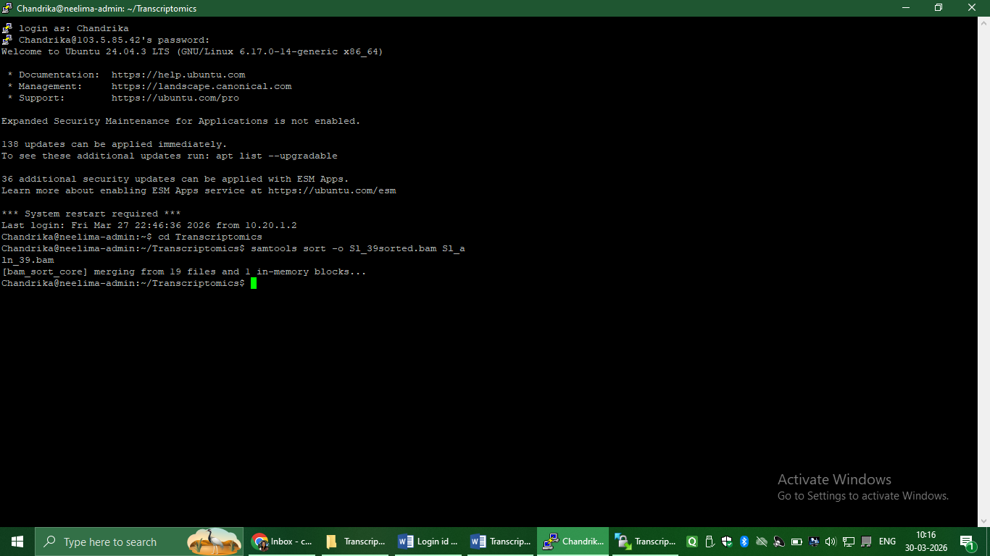
samtools sort -o Sl_40sorted.bam Sl_aln_40.bam
samtools sort -o Sl_41sorted.bam Sl_aln_41.bam
samtools sort -o Sl_42sorted.bam Sl_aln_42.bam
samtools sort -o Sl_43sorted.bam Sl_aln_43.bam
samtools sort -o Sl_44sorted.bam Sl_aln_44.bam
samtools sort -o Sl_45sorted.bam Sl_aln_45.bam
samtools sort -o Sl_46sorted.bam Sl_aln_46.bam
samtools sort -o Sl_47sorted.bam Sl_aln_47.bam
samtools sort -o Sl_48sorted.bam Sl_aln_48.bam
samtools sort -o Sl_49sorted.bam Sl_aln_49.bam
samtools sort -o Sl_50sorted.bam Sl_aln_50.bam

#Indexing of sorted bam file
samtools index Sl_39sorted.bam
samtools index Sl_40sorted.bam
samtools index Sl_41sorted.bam
samtools index Sl_42sorted.bam
samtools index Sl_43sorted.bam
samtools index Sl_44sorted.bam
samtools index Sl_45sorted.bam
samtools index Sl_46sorted.bam
samtools index Sl_47sorted.bam
samtools index Sl_48sorted.bam
samtools index Sl_49sorted.bam
samtools index Sl_50sorted.bam

#GFF file is imported
wget https://solgenomics.net/ftp/tomato_genome/annotation/ITAG4.1_release/ITAG4.1_gene_models.gff

#StringTie is a fast transcript assembler and quantifier for RNA-Seq data, typically run on sorted BAM files. #The basic command is stringtie <input.bam> -o <output.gtf> -p <cpus>, often guided by a reference annotation (-G) to assemble transcripts and estimate expression levels (TPM/FPKM)
#stringtie -p 8 -G annotation.gff3 -o output.gtf -l sample_name input.bam

/home/BIB/Software/stringtie-2.2.1.Linux_x86_64/stringtie /home/Chandrika/Transcriptomics/Sl_39sorted.bam -G /home/Chandrika/Transcriptomics/ITAG4.1_gene_models.gff -o Sl39_transcripts.gtf -A Sl39_gene_abund.tab -B -e -p 4
/home/BIB/Software/stringtie-2.2.1.Linux_x86_64/stringtie /home/Chandrika/Transcriptomics/Sl_40sorted.bam -G /home/Chandrika/Transcriptomics/ITAG4.1_gene_models.gff -o Sl40_transcripts.gtf -A Sl40_gene_abund.tab -B -e -p 4
/home/BIB/Software/stringtie-2.2.1.Linux_x86_64/stringtie /home/Chandrika/Transcriptomics/Sl_41sorted.bam -G /home/Chandrika/Transcriptomics/ITAG4.1_gene_models.gff -o Sl41_transcripts.gtf -A Sl41_gene_abund.tab -B -e -p 4
/home/BIB/Software/stringtie-2.2.1.Linux_x86_64/stringtie /home/Chandrika/Transcriptomics/Sl_42sorted.bam -G /home/Chandrika/Transcriptomics/ITAG4.1_gene_models.gff -o Sl42_transcripts.gtf -A Sl42_gene_abund.tab -B -e -p 4
/home/BIB/Software/stringtie-2.2.1.Linux_x86_64/stringtie /home/Chandrika/Transcriptomics/Sl_43sorted.bam -G /home/Chandrika/Transcriptomics/ITAG4.1_gene_models.gff -o Sl43_transcripts.gtf -A Sl43_gene_abund.tab -B -e -p 4
/home/BIB/Software/stringtie-2.2.1.Linux_x86_64/stringtie /home/Chandrika/Transcriptomics/Sl_44sorted.bam -G /home/Chandrika/Transcriptomics/ITAG4.1_gene_models.gff -o Sl44_transcripts.gtf -A Sl44_gene_abund.tab -B -e -p 4
/home/BIB/Software/stringtie-2.2.1.Linux_x86_64/stringtie /home/Chandrika/Transcriptomics/Sl_45sorted.bam -G /home/Chandrika/Transcriptomics/ITAG4.1_gene_models.gff -o Sl45_transcripts.gtf -A Sl45_gene_abund.tab -B -e -p 4
/home/BIB/Software/stringtie-2.2.1.Linux_x86_64/stringtie /home/Chandrika/Transcriptomics/Sl_46sorted.bam -G /home/Chandrika/Transcriptomics/ITAG4.1_gene_models.gff -o Sl46_transcripts.gtf -A Sl46_gene_abund.tab -B -e -p 4
/home/BIB/Software/stringtie-2.2.1.Linux_x86_64/stringtie /home/Chandrika/Transcriptomics/Sl_47sorted.bam -G /home/Chandrika/Transcriptomics/ITAG4.1_gene_models.gff -o Sl47_transcripts.gtf -A Sl47_gene_abund.tab -B -e -p 4
/home/BIB/Software/stringtie-2.2.1.Linux_x86_64/stringtie /home/Chandrika/Transcriptomics/Sl_48sorted.bam -G /home/Chandrika/Transcriptomics/ITAG4.1_gene_models.gff -o Sl48_transcripts.gtf -A Sl48_gene_abund.tab -B -e -p 4
/home/BIB/Software/stringtie-2.2.1.Linux_x86_64/stringtie /home/Chandrika/Transcriptomics/Sl_49sorted.bam -G /home/Chandrika/Transcriptomics/ITAG4.1_gene_models.gff -o Sl49_transcripts.gtf -A Sl49_gene_abund.tab -B -e -p 4
/home/BIB/Software/stringtie-2.2.1.Linux_x86_64/stringtie /home/Chandrika/Transcriptomics/Sl_50sorted.bam -G /home/Chandrika/Transcriptomics/ITAG4.1_gene_models.gff -o Sl50_transcripts.gtf -A Sl50_gene_abund.tab -B -e -p 4

#Merging Multiple Samples:
#After running StringTie on individual samples, use the --merge mode to create a non-redundant, unified set of transcripts across all experiments.
#For this step, first we have to create a text document having gene ids in one column and transcripts.gtf files in another column and then we will create one file called gene_list.csv in the Transcriptomics folder and will paste that text file contents into it.
vi gene_list.csv
ctrl+I to get into insert mode
paste the contents of the text file into it
crtl+c to get out of the insert mode
:wq! To save the file
#To make gene count matrix and transcript count matrix
python3 /home/BIB/Software/stringtie-2.2.1.Linux_x86_64/prepDE.py3 -i /home/Chandrika/Transcriptomics/gene_list.csv -g gene_count_matrix.csv -t transcript_count_matrix.csv -v
#Then we have to create another text file named metadata.csv and there we have to paste the sample name and the conditions. And then we will create one file called metadata.csv in the Transcriptomics folder and will paste that text file contents into it.

vi metadata.csv
ctrl+I to get into insert mode
paste the contents of the text file into it
crtl+c to get out of the insert mode
:wq! To save the file
This gene count matrix file metadata.csv file is the input file for the deseq R script
#To get final PCA plot, Volcano plot and Heat map
#Transfer Rscript file to Transcriptomics folder
Rscript deseq_script.r

